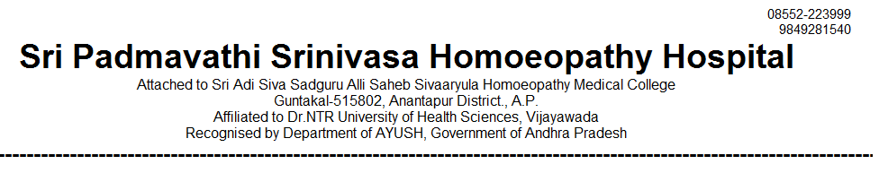
IN PATIENT STATEMENT FOR THE YEAR JAN-2024 TO DEC- 2024
SNO | MONTH | GENERAL MEDICINE | GYNAECOLOGY /OBSTERICIAN | SURGERY | PAEDIATRICS | TOTAL
1 | JAN | 58 | 21 | 12 | 9 | 100
2 | FEB | 48 | 18 | 12 | 9 | 87
3 | MAR | 61 | 28 | 10 | 9 | 108
4 | APR | 76 | 35 | 28 | 24 | 163
5 | MAY | 68 | 22 | 34 | 21 | 145
6 | JUE | 88 | 47 | 46 | 36 | 217
7 | JUL | 77 | 38 | 56 | 42 | 213
8 | AUG | 96 | 49 | 66 | 46 | 257
9 | SEP | 81 | 26 | 36 | 38 | 181
10 | OCT | 109 | 34 | 44 | 34 | 221
11 | NOV | 112 | 92 | 22 | 40 | 266
12 | DEC | 123 | 44 | 35 | 32 | 234
TOTAL | 12 MONTHS | 997 | 454 | 401 | 340 | 2192

